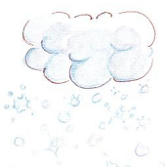
I. Unscramble and write:
- soinnwg ________________
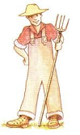

- fmerar ________________

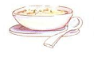
- usop ________________
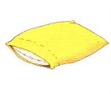

- plowil ________________

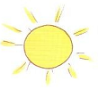
- unsny ________________

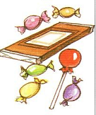
- ancdy ________________

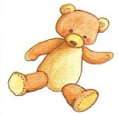
- ebar ________________
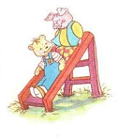

- lidse ________________

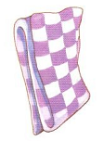
- banlekt ________________

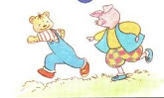
- urn ________________

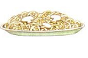
- esnolod ________________

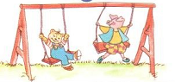
- wsngi ________________
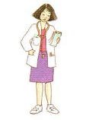

- octord ________________

II. Odd one out:
      - A. candy B. ice cream C. farmer D. chips
      - A. doctor B. green C. yellow D. red
      - A. pillow B. ice cream C. blanket D. bear
      - A. hot B. cold C. snowing D. wet
      - A. farmer B. doctor C. stop D. police officer
      - A. noodles B. soup C. farmer D. chicken
      - A. go slow B. red light C. stop D. go
      - A. sunny B. cold C. raining D. snowing
      - A. swing B. run C. chicken D. slide
10. A. wet B. cold C. soup D. hot
III. Read and match:
- I’m hungry. A. No. It’s my bear.
- It’s snowing. B. No. Not today.
- Red light. C. Have some noodles.
- Play with me. D. I’m hot.
- That’s my bear. C. Stop!
- I want chips. E. I’m wet.
- Green light. F. Ok. Let’s swing.
- It’s raining. G. Go slow.
- Yellow light. H. I’m cold.
- It’s sunny. I. Go!
IV. Unscramble and write:
1. wet. / am / I
___________________________
2. some / Have / noodles.
_____________________________
3. That’s / bear. / my
_____________________________
4. a / She’s / doctor.
_____________________________
5. want / I / ice cream.
_____________________________
6. sunny. / It’s
_____________________________
7. with / Play / me.
_____________________________
8. light. / Green / Go !
_____________________________
9. police officer. / a / is / He
_____________________________
10. It’s / my / No! / blanket.
_____________________________
V. Complete:
Stop he’s bear green want not Let’s quiet that’s with some good

A: Red light. ______________!
_________ light. Go!
B: ____________ a police officer.

A: __________ my bear.
B: No! It’s my ___________.
C: Shh! Be ______________ !

A: I _________ candy.
B: No, Sue. ___________ today.

A: Have __________ chicken.
B: Mmm. It’s ______________.
- A: Play ___________ me.
B: Ok. ___________ swing.
VI: Read and circle:
- It’s sunny. I’m __________
- wet B. hot C. cold
- I ________ hungry.
- is B. am C. m
- - I’m __________.
- Have some noodles.
- hungry B. hurry C. quiet
- – Play with me.
- _______. Let’s slide.
- Shh B. No C. Ok
- - I _______________ ice cream.
- No. Not today.
- am B. want C. have

The end

