Name: _____________________________ EXERCISES - Grade 3
A. Order the words.
1. this your ball Is ______________________________________________?
2. my this Is car ______________________________________________?
3. pencil case your This is _______________________________________________.
4. my have school things can please I
______________________________________________________________?
5. is kite this your _______________________________________________?
6. my is train this _______________________________________________.
B. Write the words in the correct box.
_______________
_______________
_______________
_______________
_______________
_______________
_______________
_______________

_________________
_________________
_________________
_________________
jobs
name
numbers
family
_______________
_______________
_______________
_______________
Billy eight mom Harry firefighter cousin farmer Milly
seven brother student nine grandpa Jamie five police officer

C. Check () the correct sentence.
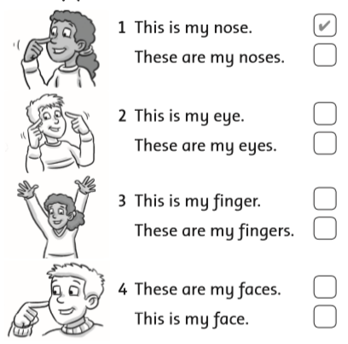

D. Look at the picture. Read and write.
kite doll teddy bear ball bike
1. A toy is under a tree. What is it? It’s a bike.
2. A toy is on the slide. What is it? It’s a _______________.
3. A toy is on the seesaw. What is it? It’s a _______________.
4. A toy is in the goal. What is it? It’s a _______________.
5. A toy is in the tree. What is it? It’s a _______________.
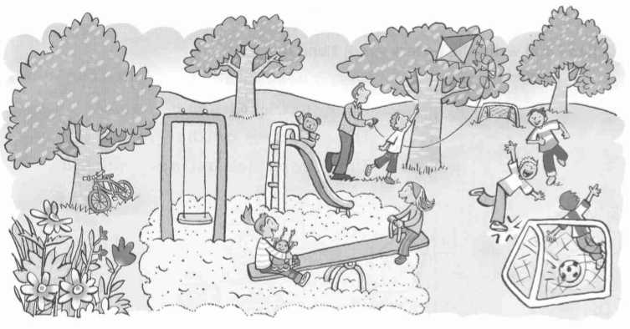
E. Read and write T (true) or F (false).
1. The ball is in the goal. ___ 2. The bike is in the tree. ___
3. The teddy bear is under the slide. ___ 4. The doll is on the seesaw. ___
5. The boys and girls are at the park. ___ 6. The kite is in the tree. ___
7. The boys are on the swing. ___ 8. The girls are on the seesaw. ___
F. Read.
1. Here’s my teddy bear. 2. What does the goat have?
3. What does the lion have? 4. What does the nurse have?
5. What does the queen have? 6. What is in the van?
7. What’s your favorite toy? 8. My favorite toy is a kite.
9. Let’s put on sunscreen. 10. She isn’t a teacher.
11. She can’t find it. 12. She can’t find her doll.
13. Where are their toys? 14. Where are the pens?
15. Where are they? 16. They’re in the pencil case.
17. The ball is in the goal. 18. This is Mom’s book.
19. It’s Billy’s teddy bear. 20. I don’t know.
21. Here are more people in my family. 22. What can you see?
23. Let’s find it. 24. Let’s find the others.
25. It’s Vinh’s sister. 26. She’s Vinh’s sister.

Name: _____________________________ EXERCISES –G rade 1
A. Match.
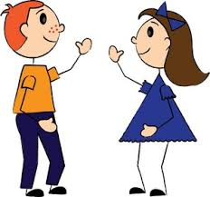

Hello! Miss Dolly Good morning! Benny Sue
B. Unscramble.
1. ’m / Benny / I /. _____________________________________________
2. I / Benny / am /. _____________________________________________
3. ’s / name / My / Sue /. _____________________________________________
4. My / Sue / is / name /. _____________________________________________
5. ’m / Miss Dolly / I / . _____________________________________________
6. name / Sue / ’s / My / . _____________________________________________
7. morning / , / Sue / Good / . _____________________________________________
8. Miss Dolly / Good / , / morning / . _____________________________________________
9. Benny / am / I /. _____________________________________________
10. boy / ’m / I / a / . _____________________________________________
11. girl / ’m / I / a / . _____________________________________________
12. a / ’m / I / teacher / . _____________________________________________
C. Complete.
1. name’s Sue
Sue: Hello, I’m ________.
Benny: Hi! My ___________ Benny.

2. Good Dolly morning
Miss Dolly: Good _________________, Benny.
Benny: ____________ morning, Miss _________.

The end

