ENGLISH EXERCISES – HKI – GRADE 4
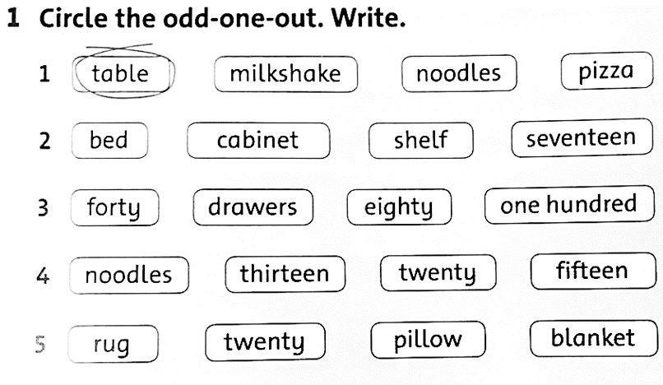
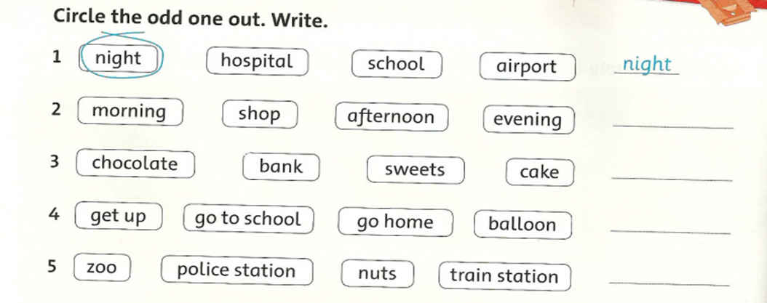
2. Reorder the words. Match.
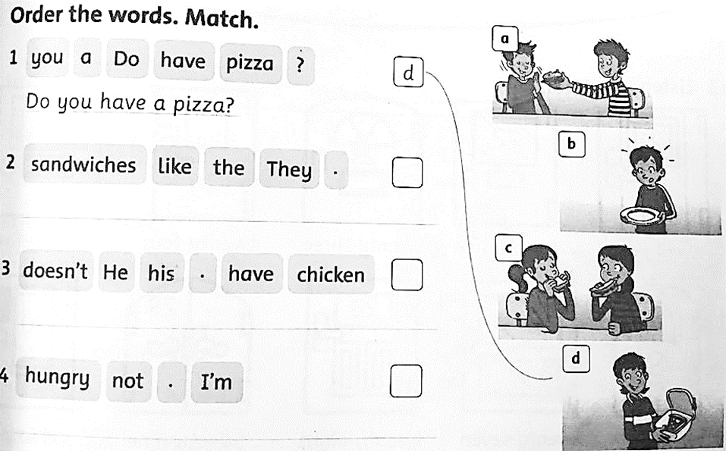
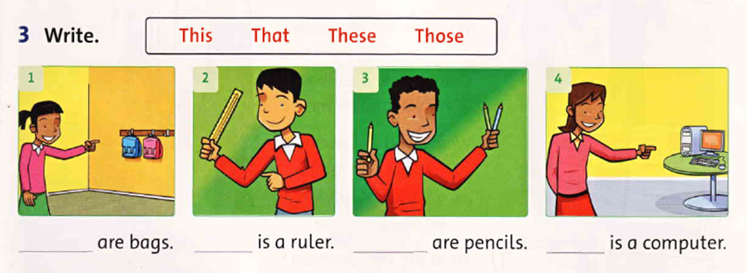
4. Write the number.
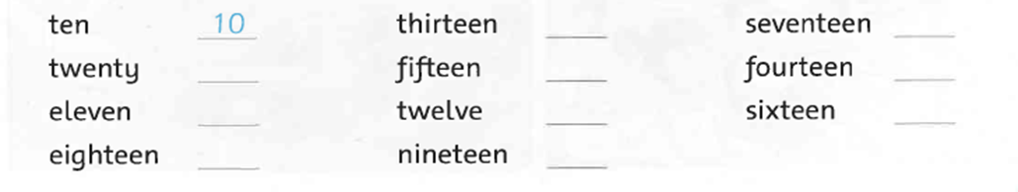
5. Look and match
1. | What do you do in the morning? | a. | No, he doesn’t. | 1, _________
2. | What time is it? | b. | It’s seven o’clock. | 2, _________
3. | Does she like balloons? | c. | I go to school. | 3, _________
4. | When do we have English? | d. | We have it on Monday. | 4, _________
5. | Does he have a sandwich? | e. | Yes, she does. | 5, _________
6. Read and answer the questions.
MY DAY
My name is Linh. This is my day.
In the morning, I get up at six o’clock.
I have breakfast – bread, eggs, and milk.
Then I go to school at seven o’clock.
I walk to school.
I take my school bag.
My pencil case and books are in my bag.
Answer the questions
1. | What’s the girl’s name?
 | _______________________________________________________
2. | What time does Linh get up?
 | _______________________________________________________
3. | What does she have for breakfast?
 | _______________________________________________________
4. | What’s in her bag?
 | _______________________________________________________
7. Look and write.
      

