I.Match
Is this Rosy’s coat ? my pants.
Are these her shoes ? No, it isn’t.
I put on yellow.
Her hat is I like green, too.
I put on my T-shirt color
I like green Yes, they are .
Orange is my favorite every day.
II.Match
What color are these pants ? She’s in the living room .
What color is this T-shirt ? They’re black.
Where’s Grandma ? It’s green.
Where’s Grandpa ? They’re in the bathroom .
Where are grandma and Grandpa ? No, they aren’t.
Are Dad and Mom in the bedroom ? Yes, he is .
Is she in he dining room ? He’s in the kitchen.
Is he in the kitchen ? I have a certificate.
Look ! No, she isn’t.
III.Reorder the words.
1.dress/ her/ This/ is/. __________________________________________________
2.T-shirt/ is/ this/ his/. __________________________________________________
3.are/ her/ socks/ these/. ___________________________________________________
4.are/ her/ socks/ these/? ___________________________________________________
5.Billy/ is/ this/ T-shirt/’s/. ____________________________________________________
6.Billy/ is/ this/ T-shirt/’s/ ? ____________________________________________________
7.is/ dress/ this/ Rosy/’s/. _____________________________________________________
8.Grandma/ where/’s/ ? __________________________________________
9.Dad/ where/Mom/ and/ are /? ___________________________________________
10.in/they/dining /room/’re/the/. ___________________________________________
11.are/ dining/ they/ in/ rom/ the/. ___________________________________________
12.kitchen/ they/ in/ are/ the/ . ____________________________________________
13.’re/They/ dining/ too/ in/the/ room/. ____________________________________________
14.teacher/ my/ is/ this/. ____________________________________________
15.chick/ little/ has/she /a/. _____________________________________________
16.family/ is/ the/ living/ in/ room/ the/. _____________________________________________
17.is/ here/ dining/ the/ room/. _____________________________________________
18.room/ living/ is/ here/ the/ . _____________________________________________
19.kitchen/is/ here/ the/ . ______________________________________________
20.are/ we/ living/in/ room/ the/. ______________________________________________
21.in/ the/ what/’s/ bedroom/? ______________________________________________
22.kitchen/ what/ the/ in/’s/ ? ______________________________________________
23.dining/what/ room/ ‘s/ in/the/ ? ______________________________________________
24.room/ favorite/ my/ is/ bedroom/ the/. ____________________________________________
25.room/ the/ my/ is/favorite/ kitchen/. ______________________________________________
26.bedrooms/ are/ where/ the/? ______________________________________________
27.where/the/are/bathrooms/? _______________________________________________
28.it/ in/ the/’s/bedroom/. ______________________________________________
IV.Complete the sentences.
1.There ____________ photos of my family.
2.Where are the bedrooms? ____________ uptairs.
3.Where’s the kitchen ? ____________downstairs.
4.My ______________ room is the kitchen.
5.My __________________ room is the living room.
6.My __________________ room is the dining room.
7.What ________ you see ? I can see a chick.
8.Are these her socks ? Yes, __________________
9.Are these his pants ? No,__________________
10.Is this Rosy’s T-shirt ? Yes, _________________
11.Is this Lan’s dress ?No, ___________________
12.I put ___________ my shoes every day.
13. I ___________ on my coat ,every day.
14.I put on _____________ dress ,every day.
15.Where’s Grandma ? _____’s in the living room.
16.Where’s grandpa ? ____’s in the dining room.
17._________they in the living room ? Yes, they are.
18.Are they in the bathroom ? No, _____________
19.___________ Lan in the living room ? Yes, she is.
20.Is Billy in the kitchen ? No, ______________
21.___________ Mom and Dad in the bathroom ? Yes, they are.
22.___________Billy and Rosy in the bedroom ? No, they aren’t.
23. Are Nga and Tuan in the bedroom ? Yes, _____________
24.Are Minh and Thu in the bathroom ? No, _____________
25.Where are Mom and Dad ? ___ ‘re in the living room.
26.Where are Minh and Thuy ? ____’re upstairs.
27.My ____________ room is the kitchen.
27.My ___________ color is blue.
28.upstairs _______________ downstairs.
29.Are these her socks ? No, _______________
30.__________is Billy ? He’s in the bedroom.
31._________’s Nam ? He’s in the bathroom.
32.Where’s grandma ? _______ is in the kitchen.
33.I have a cheese ____________ a pear.
V.Reorder the words.
1.egg/ I/ sandwiches/two/ have/. ______________________________________________
2.water/ is/my /drink/. ______________________________________________
3.an /have/ I/ don’t/ today/ apple/. ______________________________________________
4.have/ don’t/ a/I/ sandwich/ today/. ______________________________________________
5.banana/have/ don’t/I/ today/a/. _______________________________________________
6.drink/have/ I/a/don’t/today/. _______________________________________________
7.cookie/ have/today/don’t/ I/a/. _______________________________________________
8.orange/ have/an/don’t/ I/. ________________________________________________
9.have/ I/pear/a/ today/. ________________________________________________
10.sandwiches/three/ have/ I/banana/one/and/.
_______________________________________________________________________________
11.pants/ green/are/ her/.
12.T-shirt/his/black/are/.
13.blue/socks/are/ her/.
14.sheep/his/are/brown/.
15.room/favorite/my/kitchen/is/the/.
16.room/living/favorite/ my/is/the/room/.
17.bedroom/my/is/favorite/room/the/.
18.dining/room/favorite/my/room/is/the/.
19.certificate/have/I/a/.
20.dining/room/she/is/the/in/.
I.Write
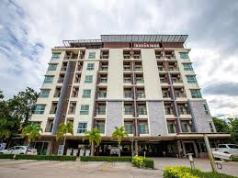 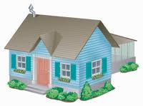____________ ________________ ____________ ____________
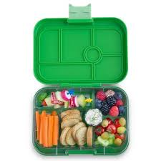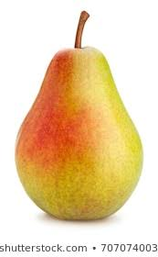
______________ _______________ ______________ _________________
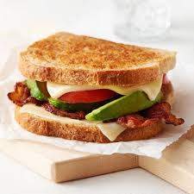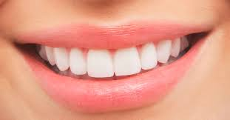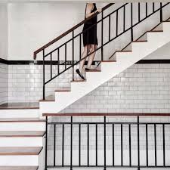
_______________ ________________ ________________ _______________
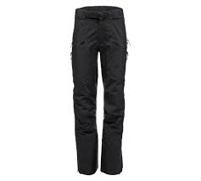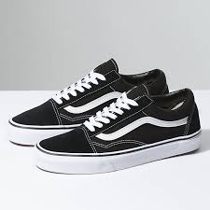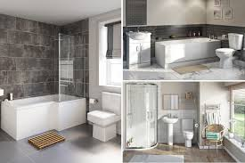
___________ ______________ _______________ ______________
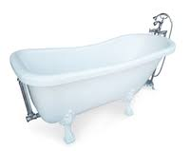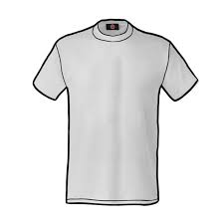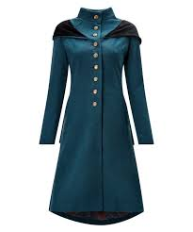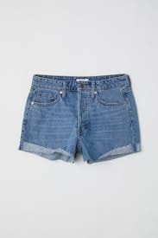
_______________ ________________ _________________ ________________
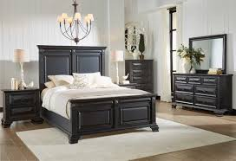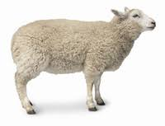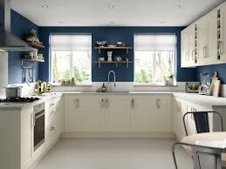
_____________________ _________________ ___________________
II.Complete the sentences.
1.Where’s Billy ? ____________ in the bedroom.
2.Where’s Rosy ? _____________ in the bathroom.
3.Where’s Grandma ? ___________ in the living room.
4.Where’s Grandpa? ___________ in the kitchen.
5.Where are Billy and Rosy ? _____________ in the dining room.
6.Where are Mom and Grandpa ? ______________ in the kitchen.
7.I don’t have _______orange.
8.I don’t have ________ apple.
9.I have _______ banana.
10.I have __________ tomato and ______ cookie.
III.Read and complete the sentences.
My name’s Minh.I live in an apartment.I live with my grandma , my grandpa and my brother in Ha Noi.There are three bedrooms in my apartment.One bedroom is for my grandpa.One bedroom is for my grandma and me.The other bedroom is for my brother.There is a kitchen, a living room and a bathroom ,too.
1.Minh lives in an ____________________
2.Minh lives with _______________________________
3.There are ________________bedrooms.
4.There is ___________ bathroom , too.
5.One ____________ is for Minh’s grandpa.

