ĐỀ CƯƠNG ÔN TẬP ANH VĂN LỚP 1
Exercise 1: Look and circle.
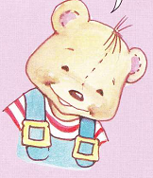  BENNY/ SUE | 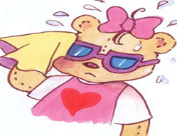  SUE/ BENNY
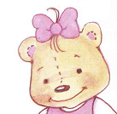  SUE/ BENNY | 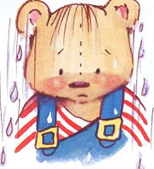  BENNY/ SUE
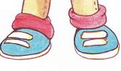  SUE/ BENNY | 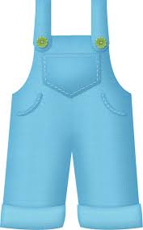  SUE/ BENNY
SUE/ BENNY | 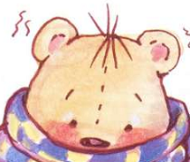  SUE/ BENNY
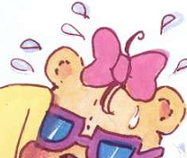  SUE/ BENNY | 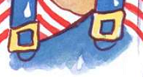  SUE/ BENNY

Exercise 2: or
BENNY | 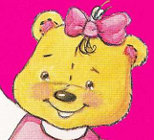 | 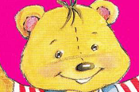
SUE | 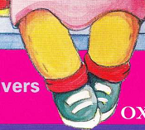 | 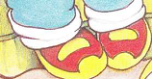
BENNY | 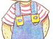 | 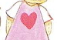
SUE | 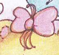 | 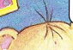
BENNY | 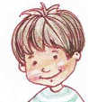 | 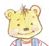

Exercise 3: Odd one out
1 | A. Benny | B. Sue | C. wet
2 | A. hello | B. cold | C. hi
3 | A. Benny | B. hi | C. hello
4 | A. hello | B. Benny | C. Sue
5 | A. Benny | B. hello | C. Sue

Exercise 4: Find out “SUE, BENNY, and HELLO”
B | E | N | N | Y | H | S
E | U | S | U | E | E | U
N | S | U | E | Y | L | E
N | U | E | U | N | L | H
Y | E | U | S | N | O | E
Y | U | S | U | E | E | L
H | S | U | E | B | U | L
H | E | L | L | O | S | O
Exercise 5: Look and match
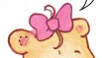 | BENNY
 | HELLO | 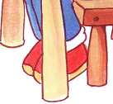
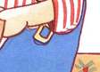 | SUE

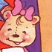 | SUE | 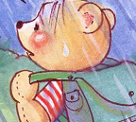
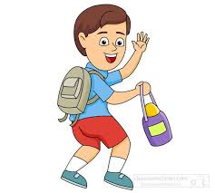 | BENNY | 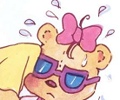
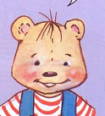 | HELLO | 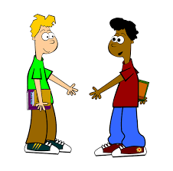
Exercise 6: Look and write u, e, a, o, i
B__nny | S__e | Su__ | Hell__
H__llo | H__ | S__ __ | H__ll__

Exercise 7: Look and write:
- y n n e B > ……… | - u e s > …………
- n n e y b > ………. | - S e u > ……………
- e u s > …………… | - y n e n b > …………..

Exercise 8: Write Benny, Sue or Hello
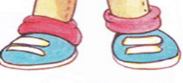  ……………. | …………….
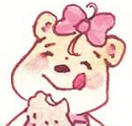  ………….. | 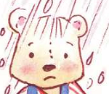  ……………….
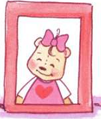  …………….. | 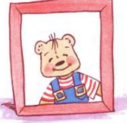 …………….
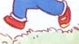  …………….. | 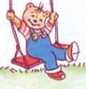  ………………….
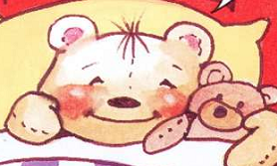  ……………… | 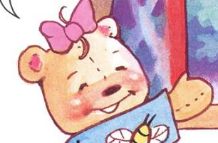  ……………

Exercise 9: Look and circle
- I’m Benny.  - I’m Sue. | 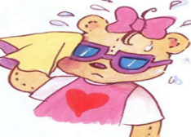  A.I’m Benny.  B.I’m Sue.
- Hello  - I’m Sue. | - Hi,  - I’m Benny.

Exercise 10: Rewrite
No | sentences | sentences
1 | ’m/Benny./ I | ………………………
2 | I/ hello / Sue/’m | ………………………
3 | I/ Sue./’m | ………………………
4 | Sue/ I /’m | ………………………
5 | Benny /’m/ I | ………………………

Exercise 11: Read and rewrite
No | Pictures | Answer
1 | 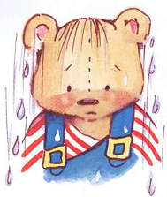 | I’m ……………
2 | 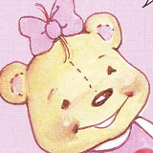 | I’m………………
3 | 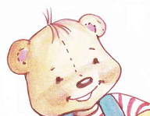 | ……………………

Exercise 12: Look and circle.
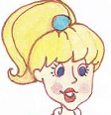  Miss Dolly/ SUE | SUE/ BENNY
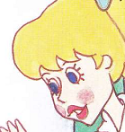  Miss Dolly/ BENNY | BENNY/ Miss Dolly
SUE/ BENNY | SUE/ Miss Dolly
SUE/ BENNY | 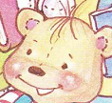  SUE/ BENNY
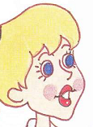  SUE/ BENNY | SUE/ BENNY
Exercise 13: Odd one out
1 | A. Good morning | B. Sue | C. Hi
2 | A. Hello | B. Miss Dolly | C. Hi
3 | A. Sue | B. Miss Dolly | C. Benny
4 | A. Miss Dolly | B. Benny | C. Hello
5 | A. Miss Dolly | B. Hello | C. Hi
Exercise 14: Look and match
 | BENNY | 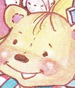
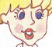 | Miss Dolly | 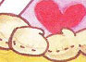
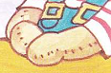 | SUE | 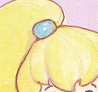

 | Miss Dolly | 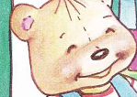
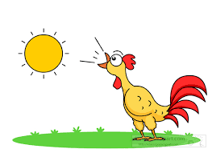 | BENNY | 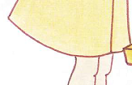
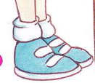 | Good morning
Exercise 15: Look and write u, e, a, o, i
S__ e | M__ss D__lly | H__llo | G__od morning
Su__ | B__nny | H__ | Good morn__ng

Exercise 16: Look and write:
- n n e B y > ……… | - i s s m l l d o y > …………
- e n n y B > ………. | - o h l l e > ……………
- e u s > …………… | - m r o n i n g > …………..

Exercise 17: Rewrite
No | sentences | sentences
1 | name’s/ Sue/ My | ………………………
2 | morning , / Good/ Benny | ………………………
3 | Miss/ name’s / Dolly / My | ………………………
4 | Benny/ My/ name’s | ………………………
5 | Dolly /’m/ I / Miss | ………………………

Exercise 18: Read and rewrite
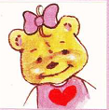  My name’s……. | 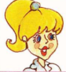  ……………………. | 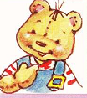  ………………….

Exercise 19: Look and circle.
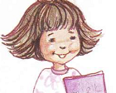  girl / boy | boy / teacher
teacher / Benny | 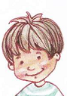  boy / Benny
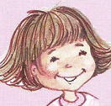  teacher / girl | 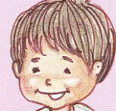  boy / teacher
boy / girl | Benny / Miss Dolly
Miss Dolly / boy | Benny / teacher

Exercise 20: Look and match
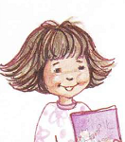 | boy | 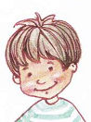
 | girl
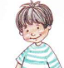 | teacher

 | girl | 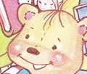
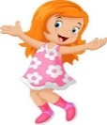 | Benny
 | girl
Exercise 21: Look and write:
- g l r i > ……… | - t e c h a r e > …………
- y b o > ………. | - b e n y n> ……………
- e a c h t e r > …………… | - u e s > …………..
Exercise 22: Write “boy, girl, and teacher”
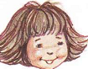………………… | …………………..
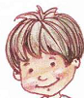………………….. | 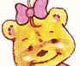…………………
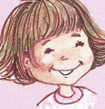………………… | ………………….
…………………… | 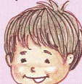………………….
……………………. | 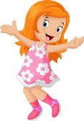……………………
Exercise 23: Look and circle
- I’m a boy.  - I’m a girl. | - I’m a teacher.  - I’m a girl.
- I’m a teacher.  - I’m fine, thank you. | 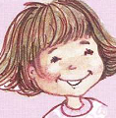  - I’m a girl.  - I’m a teacher.

Exercise 24: Rewrite
No | sentences | sentences
1 | a / I / ’m / boy. | ………………………
2 | girl / ’m / a / I | ………………………
3 | I / a / teacher / ’m | ………………………
4 | my / ’s / name / Benny | ………………………
5 | fine / ’m / I | ………………………

Exercise 25: Match
- Hello  - How are you?  - What’s your name?  - Good morning | - I’m Benny.  - Hi  - Good morning  - I’m fine
Exercise 26: Read and correct
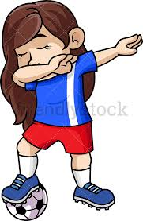  I’m a boy.  ………………… | I’m a teacher.  ………………… | My name’s Sue.  …………………
I’m a boy.  ………………… | I’m a boy.  ………………… | I’m a teacher.  …………, thank you.
I’m a girl.  ………………….. | My name’s Miss Dolly.  ………………………. | I’m a girl.  ………………….
I’m a teacher.  ……………………. | I’m a girl.  …………., thank you. | 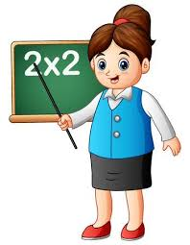  I’m a boy.  …………………

