TÀI LIỆU ÔN TẬP - LỚP 2 : TINY TALK 1B ( TEST 1 )
Họ tên HS: ______________Lớp: 2/__
EX1: . Look, read and write into the sentence: ( Nhìn, đọc và viết thành câu)
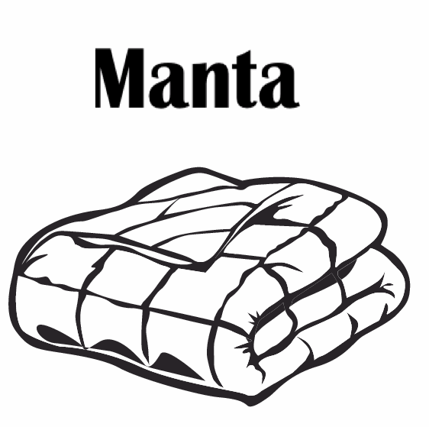 | Sue: That’s my blanket.  Benny : No, It’s my blanket.
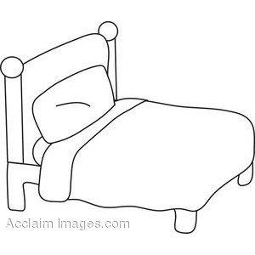 | Sue:_________________  Benny:_______________
Sue:_________________
Benny:_______________
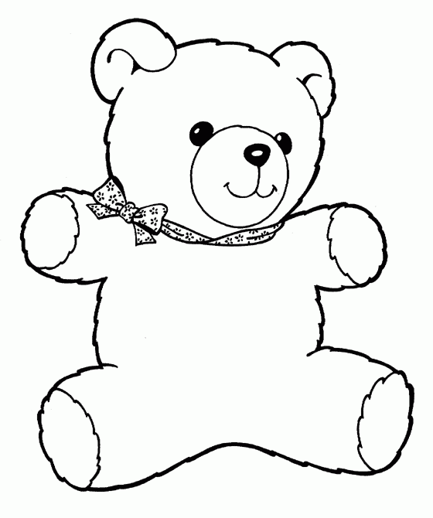 | Sue:_________________  Benny:_______________
Sue:_________________
Benny:_______________

EX 2:Look and write the words (nhìn và viết lại)
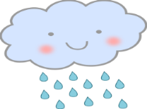 |  | 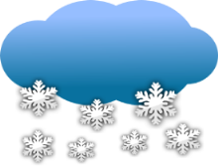 |  | 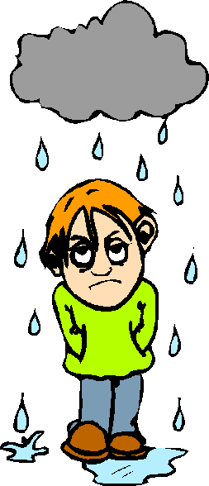
raining
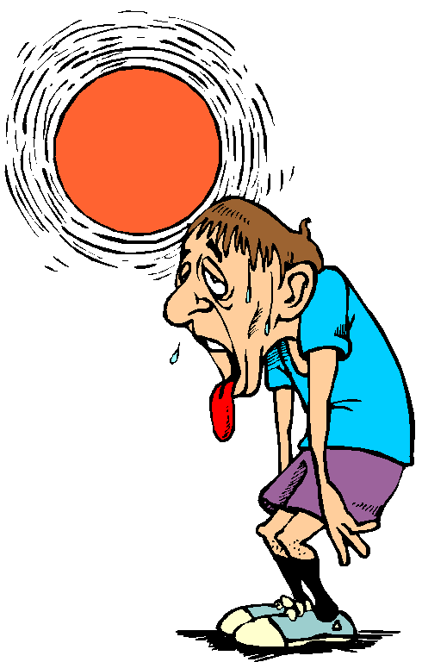 |  | 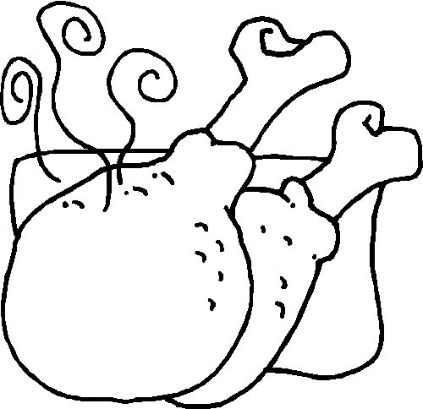 |  | 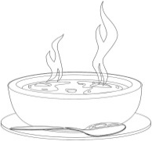
 |  |  |  | 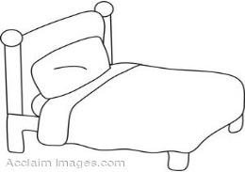

EX 3: Choose the best word: (chọn từ đúng)
Pillow be quiet! Bear blanket bed

1. bear | 2. ------------------ | 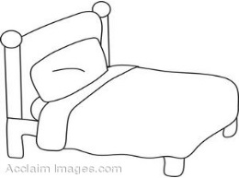  3. ------------------ | 4. ------------------ | 5. ------------------

EX 4 : Choose the best answers: (Chọn đáp án đúng)
1. It’s my _____  a. blanket  b. bed  c. Be quiet! | 2. I’m ________  a. hot.  b. wet.  c. sunny. | 3. Have some _____  a. hungry  b. soup  c. chicken
4. Be _____  a. quiet!  b. cold  c. blanket | 5. It’s _________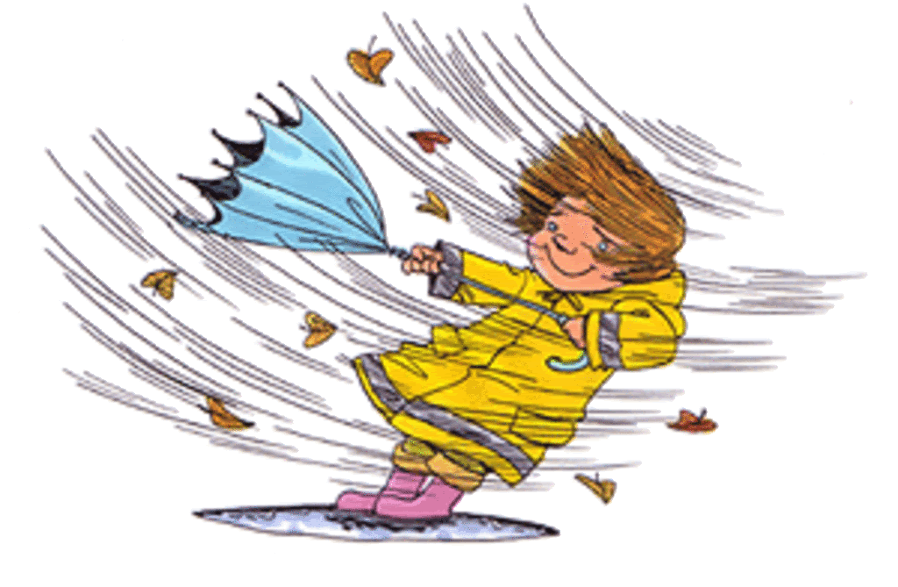  a. cold.  b. windy.  c. hungry. | 6. It’s my _____  a. noodles  b. bear  c. pillow
7. _____ cloudy.  a. I’m  b. It’s  c. cloudy | 8. Have some_____  a. noodles  b. cold  c. chicken | 9. I’m _______  a. raining.  b. snowing.  c. wet.
10. I’m_______  a. cold  b. hungry  c. wet | 11. It’s _________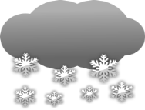  a. chicken.  b. cloudy.  c. snowing. | 12. It’s ____ bed.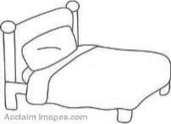  a. I’m  b. bear  c. my
13. _____ cold.  a. I’m  b. It’s  c. Be quiet ! | 14. It’s my _____  a. bed  b. bear  c. pillow | 15. It’s _________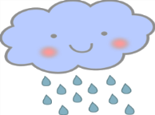  a. sunny.  b. wet.  c. raining.

