REVIEW

Phu My Primary school  Class : 2/___ | Student’s name :  ______________________
Look at the picture and write.
 | 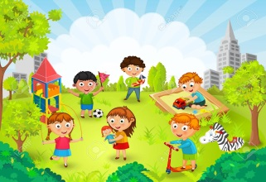 |  | 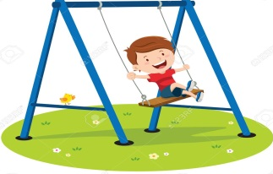
I. Odd one out.
1. purple wet yellow green.

2. chicken stop noodles soup.

3. slide chicken run swing.

4. chips ice cream candy run.

5. sunny pillow blanket bear.

6. police officer red light farmer doctor .

7. red light green light teacher yellow light
II. Reorder the sentences
- my/ That’s/ blanket
___________________________________________
- snowing/ is / It
_________________________________________
- is / It /chicken / my
___________________________________________
- is/ She/ police / a / officer.
___________________________________________
- am / I / wet.
___________________________________________
- I/ hungry/ am.
___________________________________________
- some / Have / soup.
___________________________________________
- is/ He/ famer/ a
___________________________________________
- want / ice / I / cream
___________________________________________
- Red / stop / light.
___________________________________________
III. Leave me out
1. raeining → raining
2. hote → ……………….
3. suanny → ……………….
4. weat → ……………….
5. coeld → ……………….
6. snouwing → ……………….
7. seoup → ……………….
8. chiecken → ……………….
9. noeodles → ……………….
10. piellow → ……………….

